Test Case: tc001_SPX_Dev5_Crear_Solicitud_Articulo_Almacen
Step 1 - Enter username and password and click to button Enter : Credentials Entered
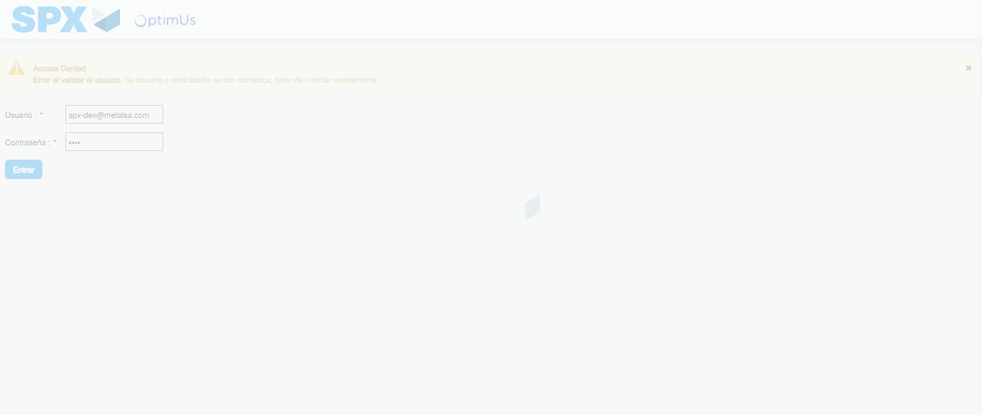Image file-name: QC_Testing-tc001_SPX_Dev5_Crear_Solicitud_Articulo_Almacen-1788280180406

Step 2 - Select to UEN and Access to Request for a New Inventory Item : UEN Correctly selected and Correct access
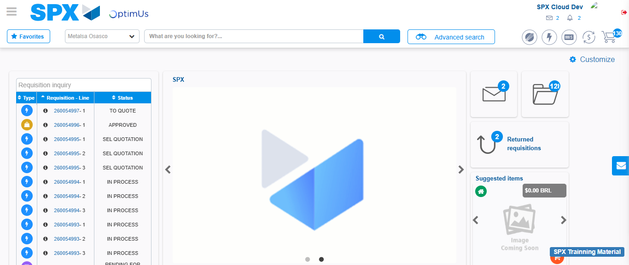Image file-name: QC_Testing-tc001_SPX_Dev5_Crear_Solicitud_Articulo_Almacen-1788280208124

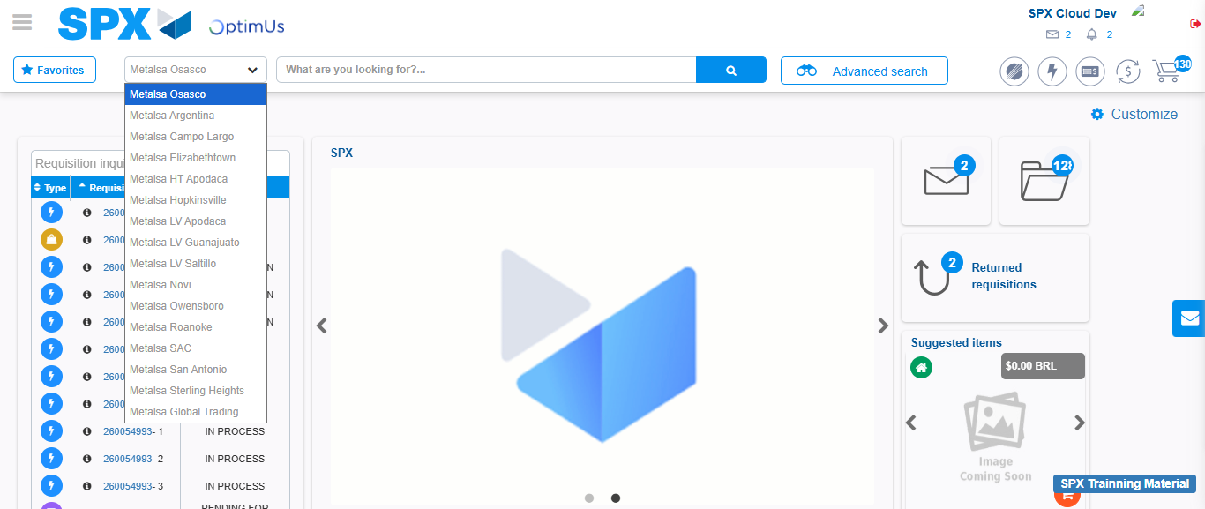Image file-name: QC_Testing-tc001_SPX_Dev5_Crear_Solicitud_Articulo_Almacen-1788280208764

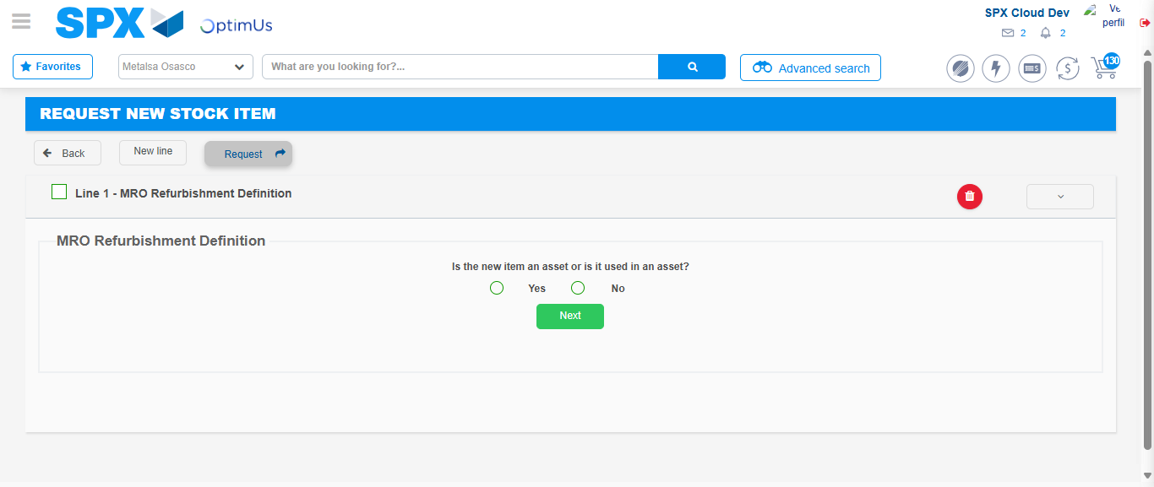Image file-name: QC_Testing-tc001_SPX_Dev5_Crear_Solicitud_Articulo_Almacen-1788280230998

Step 3 - Select options first section : Options seleted correctly
Image file-name: QC_Testing-tc001_SPX_Dev5_Crear_Solicitud_Articulo_Almacen-1788280231251

Image file-name: QC_Testing-tc001_SPX_Dev5_Crear_Solicitud_Articulo_Almacen-1788280231459

Step 4 - Select options at Screen: Options seleted correctly
Image file-name: QC_Testing-tc001_SPX_Dev5_Crear_Solicitud_Articulo_Almacen-1788280231251

Image file-name: QC_Testing-tc001_SPX_Dev5_Crear_Solicitud_Articulo_Almacen-1788280231459

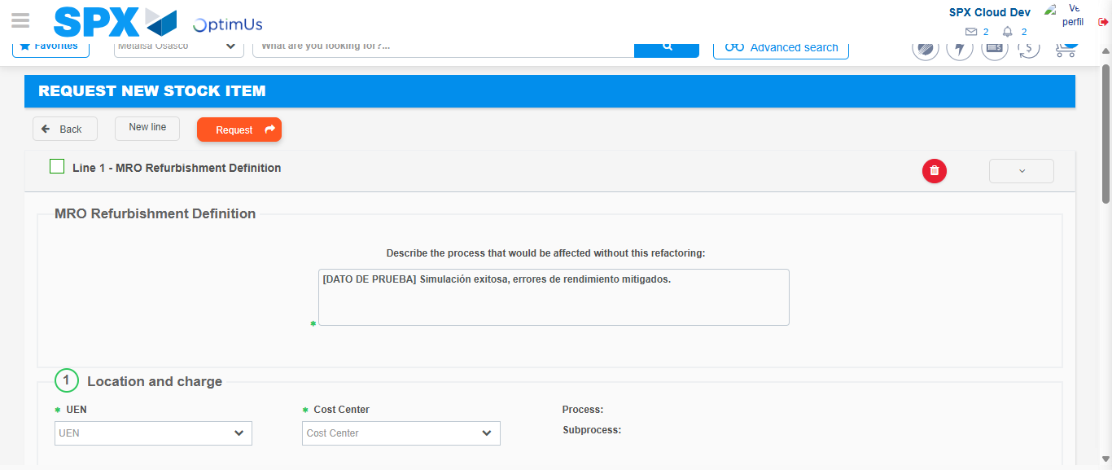Image file-name: QC_Testing-tc001_SPX_Dev5_Crear_Solicitud_Articulo_Almacen-1788280243101

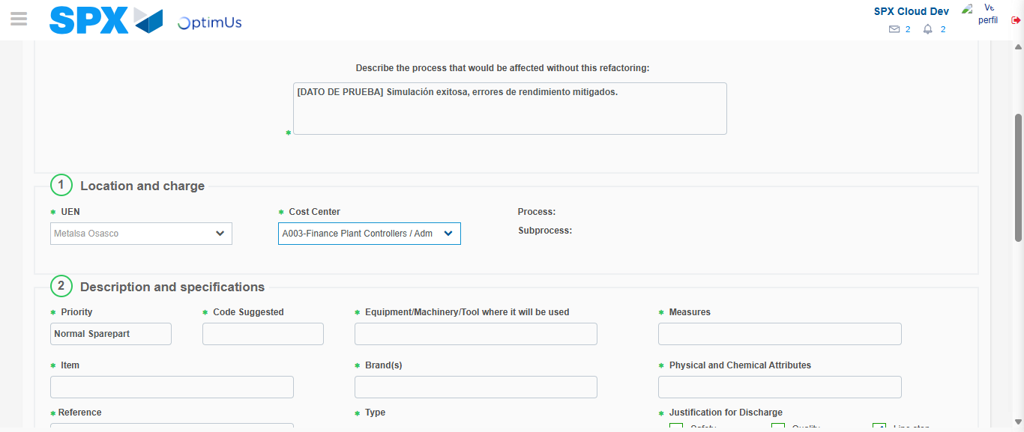Image file-name: QC_Testing-tc001_SPX_Dev5_Crear_Solicitud_Articulo_Almacen-1788280246381

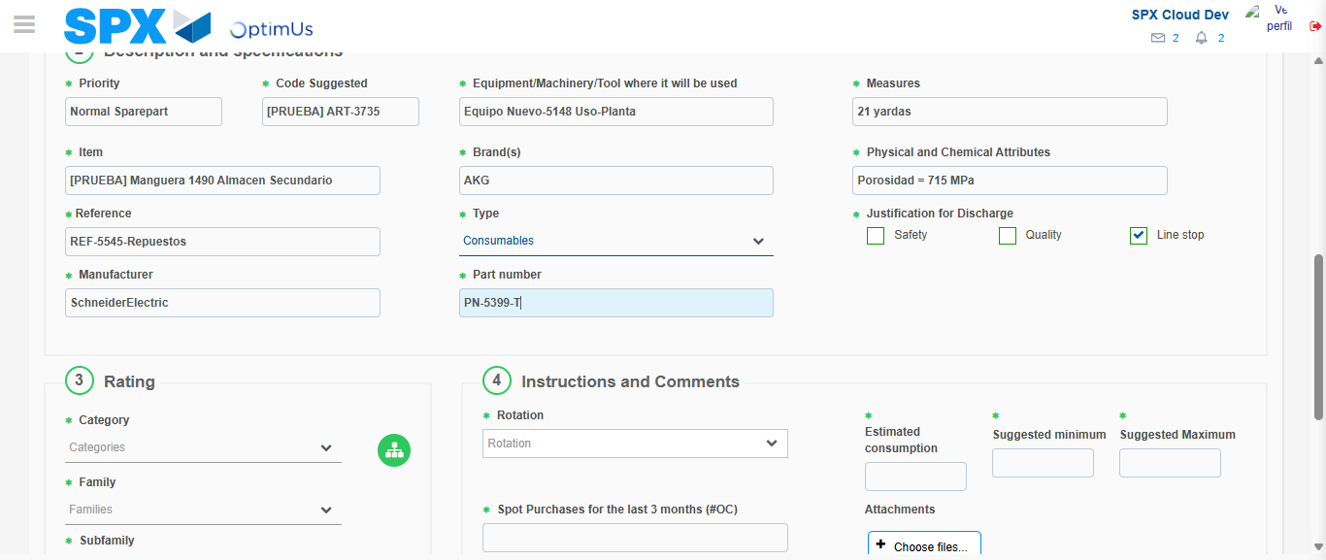Image file-name: QC_Testing-tc001_SPX_Dev5_Crear_Solicitud_Articulo_Almacen-1788280248309

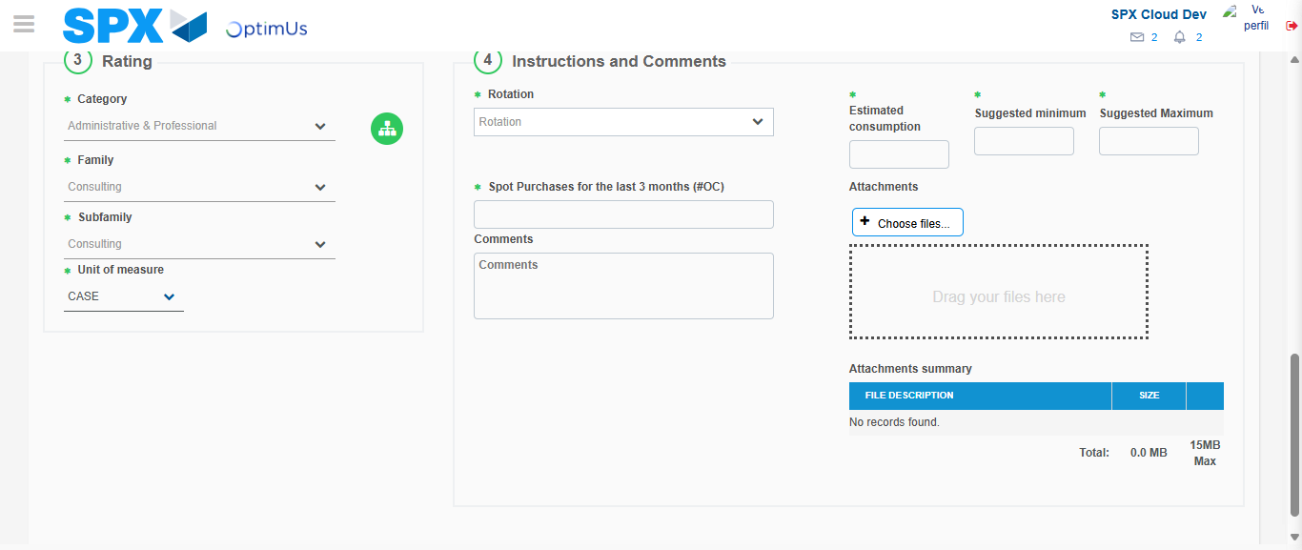Image file-name: QC_Testing-tc001_SPX_Dev5_Crear_Solicitud_Articulo_Almacen-1788280253337

Step 5 - Request New Item : Request Accepted
Image file-name: QC_Testing-tc001_SPX_Dev5_Crear_Solicitud_Articulo_Almacen-1788280208124

Image file-name: QC_Testing-tc001_SPX_Dev5_Crear_Solicitud_Articulo_Almacen-1788280208764

Image file-name: QC_Testing-tc001_SPX_Dev5_Crear_Solicitud_Articulo_Almacen-1788280230998

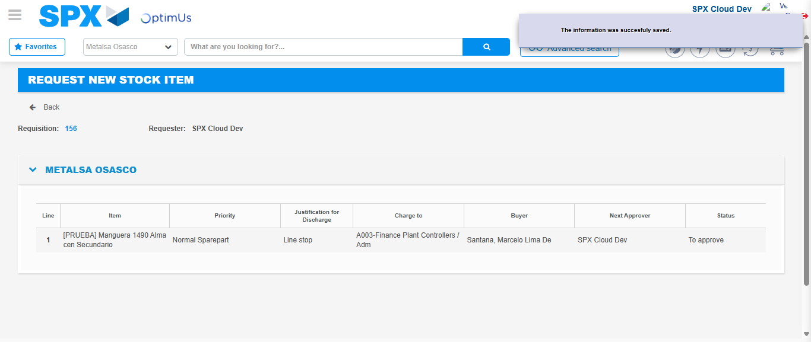Image file-name: QC_Testing-tc001_SPX_Dev5_Crear_Solicitud_Articulo_Almacen-1788280260571

Image file-name: QC_Testing-tc001_SPX_Dev5_Crear_Solicitud_Articulo_Almacen-1788280260758

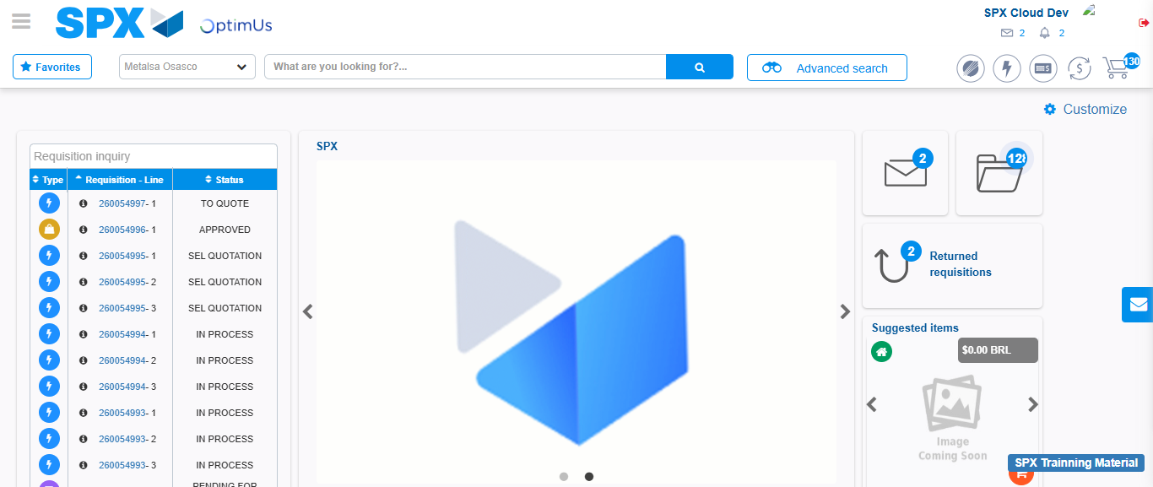Image file-name: QC_Testing-tc001_SPX_Dev5_Crear_Solicitud_Articulo_Almacen-1788280282332

Step 7 - Return to Main Page SPX : Return to Main Page SPX
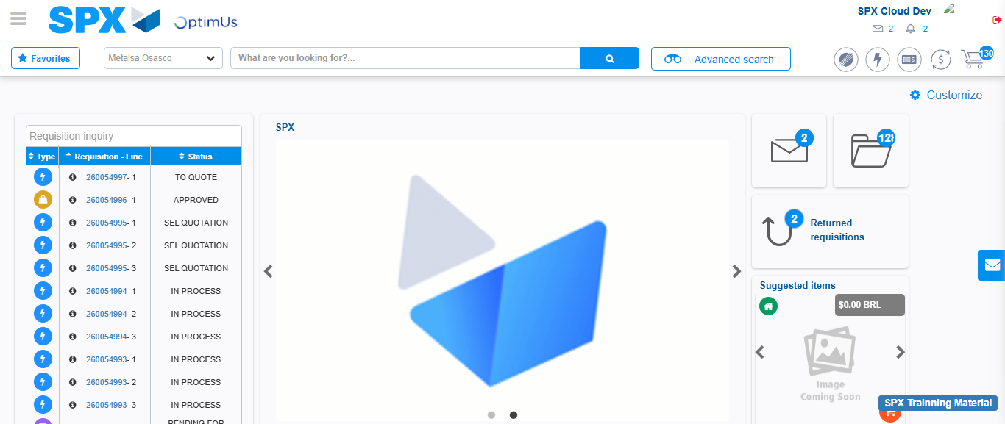Image file-name: QC_Testing-tc001_SPX_Dev5_Crear_Solicitud_Articulo_Almacen-1788280282672

